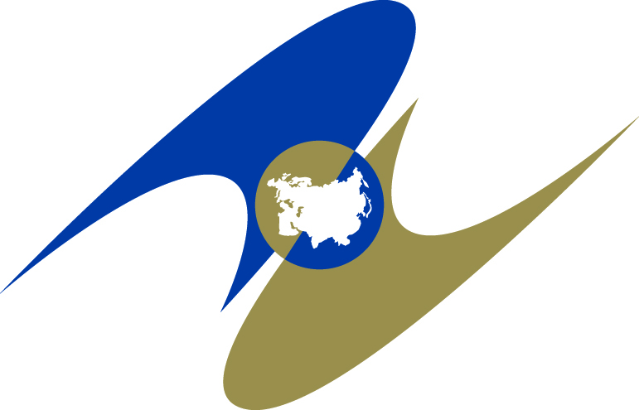

THE EURASIAN ECONOMIC COMMISSION
THE COUNCIL

DECISION

March 30, 2023 | No. 50 | Moscow

On amending Decision No. 46 of the Eurasian Economic Commission's Council dated February 12, 2016

In accordance with Paragraph 2, Article 31 of the Treaty on the Eurasian Economic Union dated May 29, 2014, Paragraphs 2 and 4, Article 4 of the Agreement on Unified Principles and Rules for the Circulation of Medical Devices (Medical Accessories and Medical Equipment) within the Eurasian Economic Union dated December 23, 2014, Paragraph 92 of Annex 1 to the Rules of Procedure of the Eurasian Economic Commission approved by Decision No. 98 of the Supreme Eurasian Economic Council dated December 23, 2014, the Eurasian Economic Commission's Council decided:
1. To make the following amendments to Decision No. 46 of the Eurasian Economic Commission's Council dated February 12, 2016 "On the Rules for Marketing Authorization and Expert Examination of Medical Device Safety, Quality and Efficiency":
a) repeal paragraph 2;
b) revise the second indent of paragraph 1 of the Rules for Marketing Authorization and Expert Examination of Medical Device Safety, Quality and Efficiency approved by the above Decision to be read as follows:
“The requirements of these Rules may not apply to medical device the need for which arises or increases in emergency situations, under conditions of military operations, the threat of spread of new epidemic diseases posing danger to others, with the risk of lack or absence of medical devices on the markets of the Union Member States (hereinafter referred to as the Member States) in the context of restrictive economic measures introduced against at least one of the Member States. The marketing of such medical devices within the Member States shall be regulated by the legislation of such Member States during the validity of these conditions and elimination of their consequences.”.
2. This Decision shall come into effect after 30 calendar days have elapsed from the date of its official publication.

Members of the Eurasian Economic Commission's Council:

For the Republic of  Armenia | For the Republic of  Belarus | For the Republic of  Kazakhstan | For the  Kyrgyz Republic | For the Russian  Federation
M. Grigoryan | I. Petrishenko | S. Zhumangarin | A. Kasymaliev | A. Overchuk

